**Research on the design for material used for the Structures:**

In a lot of the games similar to our own which we looked at and talked about in the beginning of development there are a lot of repeated materials used for the destructable structures. These includes wood, stone and metal. This is the case for most games like Angry Birds as seen below, where there are pre-generated structures laid out in the game using a variety of shapes for each material.

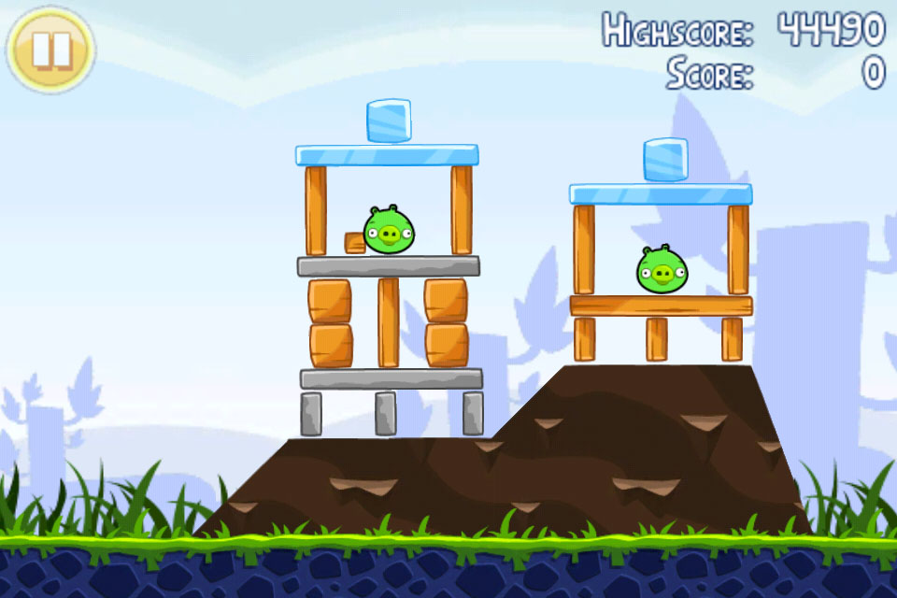

As seen above you have many different lengths and widths to the shapes, some of which are shown as being made of a different material. These materials are stone which are usually placed towards the bottom of these structures, wood that is usually placed in the middle and makes up most of the structure as it would be the most common material to obtain for example. Then you would on occasion have the inclusion of glass, this would usually be placed on the top or sides of the structure.

From the research observed and collected so far there are multiple traits and consistencies that go into the design of these commonly used materials. One defining trait they all have is their shape, they all come in different sizes and lengths and widths, to accommodate variety and to break up the geometry of the structure.

Another trait that some games using these materials utilize is the applying of different properties to the different materials. For example in Crush the Castle there are different materials used in different ways as they react differently, depending on what material they are and what they are being hit with. For example in Crush the Castle, a fire based projectile when thrown at wooden blocks will set them on fire and destroy them instantly. If there was a metal strut and it was being hit with a small boulder the damage to it would be minimal. These are examples of how we can use different materials and different projectiles to create a more dynamic and unpredictable gameplay.

Below are simply some examples and references found throughout many different sources and games what show off the use of these materials for us to pick from:

